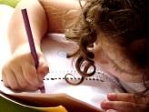  Literacy and WCR  In Talk 4 Writing, this half term, Year 3 will be exploring the genre of a cumulative story. We will be writing our own cumulative story focusing on the key literary devices focusing on varying sentences to build tension and suspense. We will then be having a debate around cooking and writing a discussion text from this.  Year 3 will continue reading “The Abominables” from Pie Corbett’s reading spine. | Maths  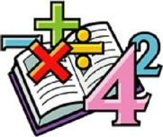  In Maths, we will be looking at more formal methods of multiplication and division.  Further on in the half term, we will be moving on to length and perimeter.  We will continue to develop our arithmetic skills to which we can apply to help us solve problems.  We will continue to complete daily times tables practise. | Science  In Science, this half-term, we will be looking into the topic “Forces”  This includes looking at contact and non-contact forces. We will be conducting experiments and reflecting upon them through conclusions. | Computing  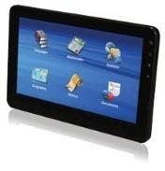  In Computing, Year 3 will be exploring the world of networking.  We will be learning about how search engines work to provide information for us. Later on in the term, we will be looking at online communications – emailing.
Humanities  In History, Year 3 will be looking at the Tudor era. Year 3 will be comparing the differences between rich and poor lifestyles within this period. | Overdale Community Primary School  Year 3 Spring 1 – 2024  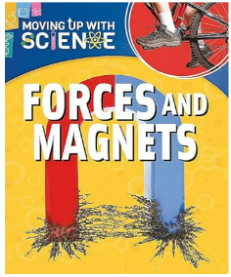  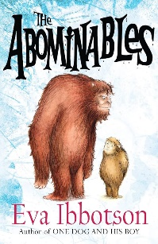 |  | 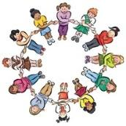  RHE/PSHE  This term in PSHE, Year 3 will be looking at Citizenship.  Year 3 will be exploring human rights and children’s rights. We will look at what it means to be a part of a community.
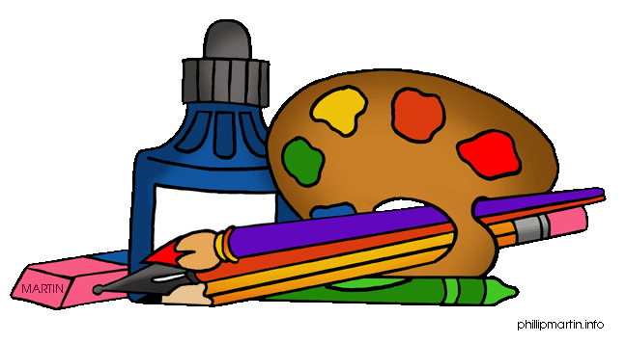  Art and DT  In Art, we will be working with shape and colour. Year 3 will explore different artists interpretations and research the media used. Year 3 will use printing, shape making and collage. | PE  This term in PE, we will be looking at dance from around the world and creating our own routine from a poem.  Year 3 will be practising their basketball skills by learning how to dribble, chest pass and play competitively in a team. | French  In French, we will be looking at counting in French. We will be able to use numbers to play outdoor playground games.  Music  In Music, Year 3 will be looking at composition and notation to perform a Viking song. | RE  In RE, we will be looking at a key question.  Our key question this half term is:  “Why are festivals important to religious communities?” Eid focus

Homework: Year 3 have been given homework book with weekly tasks to complete that relate to learning that has been delivered during the week. Year 3 will have a maths task, spelling/handwriting task and a foundation subject task to complete. This is handed out every Friday and is expected to be returned the following Friday.

